VOCABULARY WORK MENU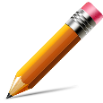 Name: #:
Directions: Choose three activities to complete using your assigned vocabulary words. Complete your activities on notebook/filler paper.

DUE DATE: _________________________________

Required: Vocabulary words must be WRITTEN IN COLOR & SPELLED CORRECTLY.

“Marvel” Me with your Comic:  Create an original comic strip using all of your vocabulary words. | “Figure” It Out  Create a stick figure drawing that represents each vocabulary word, along with a dialogue bubble or caption that correctly uses the word.  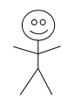 | Synonyms/Antonyms Clouds:  Find two or more synonyms & two or more antonyms for your vocabulary words. Create a cloud for each one.
Poem  Write a poem that contains three of your words and explains their meanings. | Flash Cards  Make a set of flash cards for studying your words.  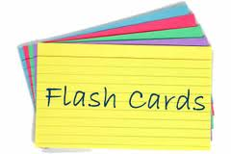 | Game On!  Create a word game that includes ALL words, such as BINGO, word search, crossword puzzle, etc.  